

Tel: 866-949-8791
www.whytry.org

The WhyTry Program

What Is WhyTry?
The WhyTry Program is a strength-based approach to helping youth overcome their challenges and improve outcomes in the areas of truancy, behavior, and academics. It is based on sound, empirical principles, including Solution Focused Brief Therapy, Social and Emotional Intelligence, and multi-sensory learning.

This simple idea has reduced truancy, improved academics, and changed the climate of schools throughout the U.S. A recent analysis in one district showed that it tripled the graduation rate of at-risk students.

The Program is generally funded by Positive Behavioral Support (PBS) and Safe and Drug Free Schools (S&DFS) grants.

Our Mission
To help people achieve opportunity, freedom, and self-respect using education and interventions that motivates and creates positive change. We offer hope and an answer to the question “Why Try in life?” To achieve its mission, WhyTry counts on the support of thousands of professionals around the world who share our commitment to helping youth reach their potential. The key to the WhyTry Program’s success in changing lives is the power in the relationship between someone who cares and a youth who needs help.

Who Uses WhyTry?
WhyTry is currently used by counselors, social workers, special-education teachers, and administrators in over 500 school districts and mental health and correctional facilities in 48 states, Canada, and Australia, changing the lives of students with a wide variety of backgrounds and challenges.

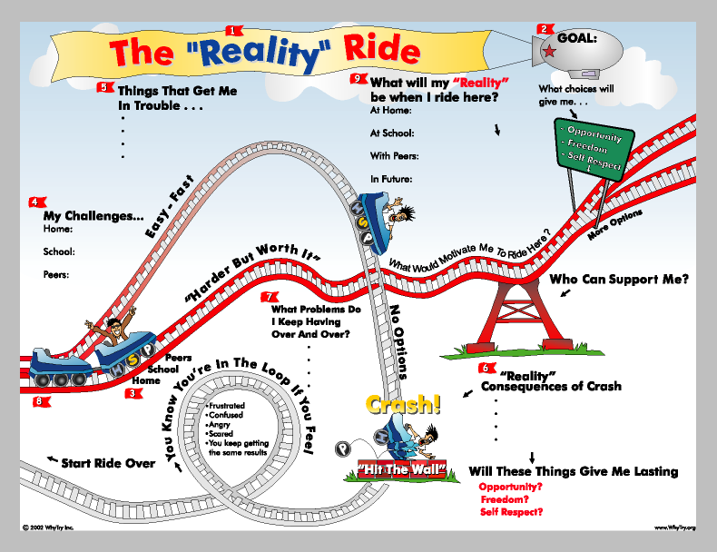
The idea is straight-forward: Teach social and emotional principles to youth in a way they can understand and remember. This is accomplished using a series of ten pictures (visual analogies). Each visual teaches a discrete principle, such as resisting peer-pressure, obeying laws and rules, and that decisions have consequences. The visual components are then reinforced by music and physical activities. The major learning styles—visual, auditory, and body-kinesthetic—are all addressed.

Facilitator Training
Tel: 866-949-8791
www.whytry.org
Professional Development Training for:
• School Counselors
• Social Workers
• Resource Teachers
• Classroom Teachers
• School Administrators
• School Psychologists

November 29-30, 2011
West Salem, WI
8:30 AM to 3:30 PM
Registration info: www.whytry.org
For more information, contact James Wilson or April Daly at 866-949-8791.
WhyTry is one of the fastest-growing behavioral programs in the U.S. for at-risk youth. It is a dynamic, easily-understood approach which is energizing professionals at every point in their career. It is the effective, hands-on solution for:
• Truancy & Drop-Out Problems
• School-Wide Behavioral Problems
• Academic Failure
Registration Form: Nov 29-30 – West Salem, WI
Name: ________________________________________ School/Organization: _________________________________
Your e-mail: ____________________________________ Your phone: ________________________________________
Shipping Address: Billing Address:
_______________________________________________ __________________________________________________
_______________________________________________ __________________________________________________
_______________________________________________ __________________________________________________
Cost: ___ $300/person (Training only)
___ $599/person (Training + Secondary Complete Curriculum) PLUS $15 Shipping ($200 Curriculum SAVINGS)
___ $599/person (Training + Elementary Complete Curriculum, includes additional music CD) PLUS $15 Shipping
Payment Amount: □ $300 □ $614 → (Payment amounts include applicable shipping charges)
Payment Method: □ Credit Card □ Check □ P.O. #______________________
If you are paying by Credit Card, please supply the following information:
Name on Card: _____________________________________________
Card Number: ______________________________________________
Expiration Date : ________________ Security Code: ______________
Card Type: □ Amex □ MasterCard □ VISA □ Discover
If you are paying by purchase order or credit card, you may fax your order form to us at: Fax # 801-377-2011
Or mail it to: WhyTry Inc.
5455 N. River Run Drive
Provo, UT 84604
Sponsored by:
CESA #4

Location:
923 East Garland St.
West Salem, WI 54669

