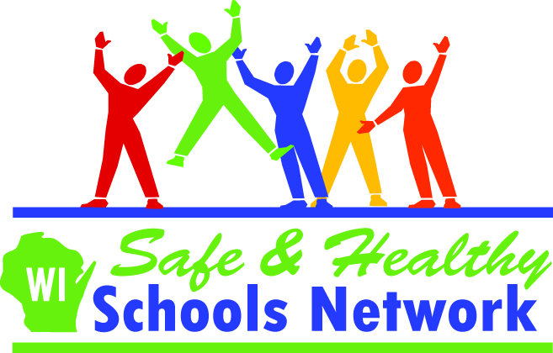
Peer Mentoring
CESA #4 Safe and Healthy Schools and Communities
Monday, December 5, 2011, from 9:00 a.m. to 2:00 p.m.
CESA #4, 923 East Garland Street, West Salem, WI 54669

Facilitator: Mike McGowan, President of McGowan and Associates, which is a training and consultation firm specializing in alcohol, drug, family, and conflict resolution issues. He has spent several years working with schools, parent groups, and students as a trainer, consultant, and motivational speaker.

Mike McGowan will give your students the skills in listening, communicating, and knowing the resources avaiable to help others. He will explain how to set up a mentoring program in your school. Think about the success of Big Brothers and Big Sisters…your school could have it to!

Mentoring is an ideal way to ease transition from elementary to middle school or middle to high school. A student trained as a mentor will be a wonderful asset to your Peer Helper Program and/or your Student Assistance Program.

Target Audience: Upper Elementary, and/or Middle School Students (Grades 4-8)

Enrollment Limit: 80 **A minimum of 20 participants is necessary to hold this workshop**
Lunch Provided!

Fee: * No fee if part of the SOH Prof. Dev. Pkg (Bangor, Sparta, Tomah, Westby)
$25 Student/Adult in ATOD Network (Alma, ACHM, Arcadia, Cashton, C-FC, De Soto, Independence, N-O-W, Whitehall)
$75 Other

For More Information: Tracy Herlitzke, therlitzke@cesa4.k12.wi.us or phone 608-786-4838

- - - - - - - - - - - - - - - - - - - - - - - - - - - - - - - - - - - - - - - - - - - - - - - - - - - - - - - - - - - - - - - - - - - - - - - - - - - - - - - - -
Peer Mentoring
New Date: Monday, December 5, 2011
9:00 a.m. – 2:00 p.m.
PLEASE REGISTER BY MONDAY, NOV. 31, 2011

All groups must be registered online. To register your group online:
Please visit http://www.cesa4.k12.wi.us/ and navigate to the calendar or the professional development page to register for the event. See http://www.cesa4.k12.wi.us/calendar/mqrinstructions.pdf for instructions on how to register using our new software.
If you need assistance with online registration contact:
Donna Elsen, Program Assistant, 608-786-4854. Thank you.

