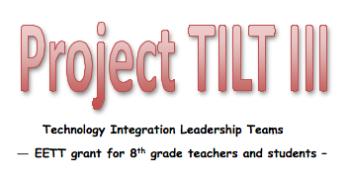
Project TILT III Sharing Session
Tuesday, May 3, 2011
8:30 a.m. – 3:00 p.m.
Glacier Canyon Lodge Conference Center
Lake Delton
— adjacent to Wilderness Resort —

Agenda
8:15 Registration and set up computers
8:30 Welcome and overview of the day Sue Fulks
8:45 Project Sharing: Be prepared to give a 5-minute overview of your
Semester II Project-Based unit including:
- CITW strategy
- instructional technology objectives
- activities
- assessments
- examples of student work
- your thoughts on how it went
9:45 Break
10:00 Project Sharing – continued
11:15 Team Sharing: What worked for your subject area? What advice would you have for other teachers in your subject area? Create script for short presentation to share with DPI.

12:00 Lunch
12:45 Project Sharing – continued
1:30 Semester II grant requirements:
- unit plans, assessments, and reflections
- student assessment
- teacher assessment
- district access to student scores
2:00 Team Sharing: Finish up script and video segment for DPI. Share strategies
and resources for continuing with Using Technology with CITW.
2:30 Evaluations
Door Prizes (great ones! must be present to win)
3:00 The End

Substitute teachers and mileage will be reimbursed.

