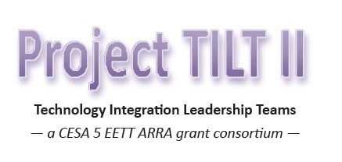
Project TILT II Coaches Meeting

Monday, October 11, 2010
8:30 a.m. - 3:00 p.m.
CESA 5, Portage
register at: http://www.myquickreg.com/

Agenda

8:15 Registration, coffee, and computer setup

8:30 Getting to know your colleagues

9:00 Review of Project TILT II Activities: unit plans, reflections, team member responsibilities, coach responsibilities, Q&A

9:30 Online Learning Communities: Overview of tools you could use:
- Jing
- Screencast
- Blogs
- Wiki
- Skype
- GoToMeeting
- Atomic Learning
- Other recommendations??

10:30 Break

10:45 Online Learning Communities
- Purpose for the learning communities
- Types of activities that could be included
- Available Resources
- Group Divisions and Coaches for each group
- Brainstorm ideas on building online professional communities:
  - In a small group, choose one of the tools listed below and record your groups ideas. Sample topics include: monthly online PD opportunities, community building activities/strategies, outside resources, etc…
  - Tools:
    - Mindmeister - http://www.mindmeister.com/
    - Wallwisher - http://www.wallwisher.com/
    - Google Docs - https://www.docs.google.com
    - Posterous - https://posterous.com/

12:00 Lunch

12:45 Construction of learning communities within Project TILT II Grou.ps site - http://grou.ps/projecttilt
- Create Group: Add photo, introduction of facilitators
- Develop an Introduction Activity
- Discuss/Develop two Discussion Prompts/Professional Development activities for group – November & December

1:30 Critical Friends Process
- Overview of Process
- Discuss how to use it with team
- Practice Session

2:30 Group Discussion:
- Planning for future Coaches Meetings – One more ‘in-person’ meeting, ‘Virtual’ – GoToMeeting, Distance Learning, etc…
- Final Video Expectations

2:45 Evaluation

3:00 Adjourn

